

International School

Capstone Project 2
CMU-SE 451

PROJECT PROPOSAL
Version 1.0
Date: February 1, 2026

SEIMS - Smart Expiry Product Integration & Management System

Created by C2SE.15
Nguyen Huy Hoang Bao - 28219004148
Nguyen Pham Nhat Huy - 28211100686
Pham Minh Trang - 28204632177
Duong Quoc Binh - 28219006390
Nguyen Huu Thang – 28211102537

Project Proposal Review Panel Representative:

Name Signature Date
Capstone Project 2 - Mentor:

Name MSc.Truong Dinh Huy Signature Date

PROJECT INFORMATION

Project acronym | SEIMS
Project Title | Smart Expiry Product Integration & Management System
Start Date | February 1, 2026 | End Date |  | April 30, 2026
Lead Institution | International School, Duy Tan University
Project Mentor | MSc.Truong Dinh Huy  Email: huy.truongdinh@gmail.com  Tel: 0982132352
Scrum master / Project Leader & contact details | Pham Minh Trang  Email: pmtrang04@gmail.com  Tel: 0911855450
Partner Organization | Duy Tan University
Team members | Name |  | Email |  | Tel
28219004148 | Nguyen Huy Hoang Bao |  | bao91ndu1819@gmail.com |  | 0385092839
28211100686 | Nguyen Pham Nhat Huy |  | huy785619@gmail.com |  | 0395546300
28204632177 | Pham Minh Trang |  | pmtrang04@gmail.com |  | 0911855450
28219006390 | Duong Quoc Binh |  | duongquocbinh@dtu.edu.vn |  | 0932033856
28211102537 | Nguyen Huu Thang |  | nguyenhuuthang11@dtu.edu.vn |  | 0702377702

DOCUMENT APPROVALS
The following signatures are required for approval of this document.
MSc.Truong Dinh Huy  Mentor | Signature | Date
Nguyen Huy Hoang Bao  Student ID: 28219004148  Team Member | Signature | Date
Nguyen Pham Nhat Huy  Student ID: 28211100686  Team Member | Signature | Date
Pham Minh Trang  Student ID: 28204632177  Project Leader | Signature | Date
Duong Quoc Binh  Student ID: 28219006390  Team Member | Signature | Date
Nguyen Huu Thang  Student ID: 28211102537  Team Member | Signature | Date

REVISION HISTORY
Version | Date | Comments | Author | Approval
1.0 |  | Create Document | All members
1.1 |  | Update Document
1.2 |  | Official Document

Table of Contents
1. Project Title 1
2. Team Members 1
3. Supervisor(s) 1
4. Problem Statement 1
5. Survey / Existing Solutions 2
6. Objectives and Scope 2
6.1. Objectives (SMART) 2
6.2. Deliverable 4
6.3. System Scope 5
7. Key Features & Requirements 6
7.1. Key Features 6
7.2. Functional Requirements (FR) 6
7.3. Non-Functional Requirements (NFR) 7
8. Constraints and Assumptions 8
8.1. Constraints 8
8.2. Assumptions 8
9. Target Users / Stakeholders 8
10. Technology Stack 9
11. Methodology & Development Plan 10
11.1. Methodology 10
11.2. Development Plan 11
12. System Architecture Overview 11
12.1 System context diagram 11
12.2 System context diagram description 13
13. Potential Risks and Mitigation Strategies 14
14. Expected Outcomes/ Deliverables 15
15. References 16

1. Project Title
SEIMS - Smart Expiry Product Integration & Management System.

2. Team Members
Table 1. Team members information
No. | Name | Email | Role
1 | Nguyen Huy Hoang Bao  Student ID: 28219004148 | bao91ndu1819@gmail.com | Backend Developer, Tester
2 | Nguyen Pham Nhat Huy  Student ID: 28211100686 | huy785619@gmail.com | Product Owner,  Backend Developer
3 | Pham Minh Trang  Student ID: 28204632177 | pmtrang04@gmail.com | Scrum Master, Frontend Developer, Design UI/UX
4 | Duong Quoc Binh  Student ID: 28219006390 | duongquocbinh@dtu.edu.vn | Frontend Developer, Tester
5 | Nguyen Huu Thang  Student ID: 28211102537 | nguyenhuuthang11@dtu.edu.vn | Frontend Developer, Tester

3. Supervisor(s)
Table 2. Mentor information
Full name: | MSc. Truong Dinh Huy
Faculty: | International School - CMU
Tel: | 0982132352
Email: | huy.truongdinh@gmail.com

4. Problem Statement
Retail businesses such as supermarkets and local stores often encounter challenges in effectively communicating product information and promotional campaigns to customers. Promotional content is frequently distributed across multiple channels, including social media platforms, printed advertisements, and individual store websites, resulting in fragmented information that makes it difficult for customers to discover and compare available promotions. In addition, certain product categories, particularly fresh or frozen food, require customers to purchase them directly at physical stores due to food safety requirements, quality assurance, and storage conditions. As a result, customers may not always be aware of ongoing promotions or available products at nearby stores, which reduces the effectiveness of marketing activities and limits customer engagement. At the same time, many small and medium-sized businesses lack a centralized digital platform where they can conveniently create a dedicated space to present their products, promotional campaigns, and store information to potential customers. Furthermore, society also faces the problem of many usable items or donated goods being discarded even though they could still provide value to people with financial difficulties.
To address these challenges, this project proposes the development of a web-based intermediary platform that connects businesses and consumers. The platform will allow businesses such as supermarkets or retail stores to create their own digital spaces to publish product information and promotional campaigns. For certain product categories such as fresh food or frozen goods, the platform will mainly function as a promotional channel where users can view product information and visit the listed store directly to make their purchase. For other product categories such as household items, electronics, and clothing, users will be able to place orders directly through the platform using features such as product browsing, shopping carts, and delivery services. In addition, the system will include a community support section that operates similarly to a charitable initiative. This feature allows organizations or individuals to donate usable items (excluding food), which can then be offered at affordable prices to people in need. To prevent misuse or reselling, the system will limit the quantity of items that each user can purchase. Through this platform, businesses can improve their promotional effectiveness, customers can more easily access product and promotional information, and the community can benefit from the redistribution of usable goods.

5. Survey / Existing Solutions
Table 3. Survey of Existing Promotion & Retail Integration Platforms

Criteria | Social Media Promotion (Facebook, Instagram) | Individual Store Websites | Online Marketplace Platforms | Proposed Retail Promotion & Community Support Platform
Centralized Promotion Information | ✗ | ✗ | Partial | ✓
Multi-Store Product & Promotion Listing | ✗ | ✗ | ✓ | ✓
Store-Specific Digital Space | ✗ | ✓ | Partial | ✓
Online Ordering & Shopping Cart | ✗ | Partial | ✓ | ✓
Support for In-Store Purchase Promotion | Partial | Partial | ✗ | ✓
Delivery Integration | ✗ | Partial | ✓ | ✓
Community Donation & Redistribution Feature | ✗ | ✗ | ✗ | ✓
Purchase Limitation for Community Support | ✗ | ✗ | ✗ | ✓

6. Objectives and Scope
6.1. Objectives (SMART)
Objective 1: Develop a Near-Expiry Product Integration Module
- Measurable Goal:
- Develop a module that supports importing product and inventory data from Excel/CSV files and simulates API-based integration.

- Success Criteria:
- Successfully import and process at least 2 data formats (Excel/CSV and simulated API).
- Ensure data consistency during import with error handling and validation.
- Maintain a unified inventory dataset across multiple stores.

Objective 2: Implement Near-Expiry Detection and Pricing Rule Engine

- Measurable Goal:
- Develop an automated system to classify inventory lots based on expiry date and apply configurable discount rules.
- Success Criteria:
- 100% of inventory lots are automatically classified (Safe, Near-Expiry, Expired).
- Discount rules are applied automatically based on remaining days.
- Allow manual override of discount values with audit logging.

Objective 3: Build Dashboard for Monitoring Near-Expiry Products
- Measurable Goal:
- Develop a dashboard to visualize inventory status and near-expiry trends.
- Success Criteria:
- Display real-time statistics of inventory status (Safe, Near-Expiry, Expired).
- Provide filtering by store, category, and date range.
- Support basic charts (bar, pie) for monitoring inventory and waste risk.

Objective 4: Develop an Early Warning and Notification System
- Measurable Goal:
- Implement a notification mechanism for key system events.
- Success Criteria:
- Notify Store Staff when products reach near-expiry threshold.
- Notify Supermarket Admin for monitoring and override actions.
- Support in-app notifications and simulated email logs.
Objective 5: Implement Secure Role-Based Access Control
- Measurable Goal:
- Develop authentication and authorization system for multiple user roles.
- Success Criteria:
- Support roles: Admin, Supermarket Admin, Store Staff, Customer, Charity.
- Ensure data isolation between supermarkets (multi-tenant).
- Secure authentication using JWT and HTTPS.
6.2. Deliverable
Deliverable 1: Functional Web-Based Near-Expiry Management Platform A fully operational web application comprising the following core modules:
- User & RBAC Module: Account management with distinct roles (Admin, Store Manager, Staff).
- Integration & Sync Module: Tools for Excel/CSV imports and RESTful API endpoints for external POS data.
- Inventory Lot Management Module: Tracking inventory by "Lot/Batch" including quantity, location, and expiry date.
- Dynamic Pricing Rule Engine: A configuration interface for setting and applying automated discount policies.
- Early Warning & Notification Module: System for generating alerts and scheduled summary reports.
- Analytics Dashboard: Visual interface for waste management and sales performance tracking.
Deliverable 2: Technical Documentation A comprehensive set of documents including:
- System Architecture Design: Overview of the tech stack (React, NestJS, PostgreSQL) and data flow diagrams.
- Database Schema (ERD): Relational design focusing on Inventory Lots, Discount Rules, and Store hierarchies.
- API Specification: Swagger/OpenAPI documentation for all backend services.
- Rule Engine Logic & Algorithms: Detailed explanation of the automated pricing and status classification logic.
- Security & Deployment Guide: Instructions for Docker-based deployment, SSL configuration, and JWT implementation.
Deliverable 3: Project Report and Final Presentation
- Project Report: A formal document covering problem analysis (food waste/loss prevention), methodology, implementation details, testing results (Unit, Integration, UAT), and future scalability.
- Final Presentation: A set of slides and a demo video showcasing the end-to-end workflow from data import to discount application.
6.3. System Scope
- Stakeholders:
- Admin, Supermarket Admin, Store Staff, Customer, Charity Organization, Delivery Partner, Project Development Team.
- Main Features:
- Supermarket registration and approval management.
- Multi-tenant governance for managing supermarkets, stores, and staff accounts.
- Inventory lot management with expiry date tracking.
- Automated near-expiry detection based on configurable threshold values.
- Automatic discount calculation using pricing rules.
- Donation management module (B2B) for charity organizations.
- Near-expiry marketplace for customers (B2C).
- Order processing and pickup management.
- Delivery status coordination.
- Dashboard and analytics for monitoring near-expiry products, donations, and sales recovery.
- Event-based notification system.
- Out of Scope:
- The system does not manage full supermarket ERP operations such as supplier procurement or full financial accounting.
- The system does not handle real-time POS integration with physical checkout systems (demo-level integration only).
- The system does not include online payment gateway integration (pickup-based model only, unless specified).
- The system does not manage warehouse logistics optimization or transportation routing algorithms.
- The system does not guarantee elimination of product waste beyond configured near-expiry handling rules.

7. Key Features & Requirements
7.1. Key Features
- Supermarket Registration and Approval Management
- Supermarket Governance and Policy Management
- Inventory Lot Lifecycle Management
- Near-Expiry Detection and Monitoring System
- Donation Management
- Marketplace and Order Management
- Delivery and Shipping Coordination
- Dashboard and Analytics Reporting
- Notification and Email Service Integration
7.2. Functional Requirements (FR)
Table 4. Functional Requirements
ID | Functional Requirement | Description
FR01 | Sign Up | Users can create an account using email and password.
FR02 | Log In | Users can log in using their registered account or Google account.
FR03 | Log Out | Users can log out to ensure account security.
FR04 | Forgot Password | Users can reset their password via email.
FR05 | Lock/Unlock User Account | Admin can lock or unlock user accounts when necessary.
FR06 | Manage Profile | Users can view and edit their personal profile; Admin can manage user profiles.
FR07 | Supermarket Registration | Supermarkets can submit a registration request to join the platform.
FR08 | Approve Registration | The system shall allow the System Admin to approve or reject supermarket registration requests.
FR09 | Store Management | The system shall allow Supermarket Admin to create, update, and manage stores
FR10 | Staff Management | The system shall allow Supermarket Admin to create and manage store staff accounts.
FR11 | Policy Configuration | The system shall allow Supermarket Admin to configure near-expiry thresholds and discount policies.
FR12 | Create Inventory Lot | The system shall allow store staff to create inventory lots including lot code, expiry date, and quantity.
FR13 | Validate Expiry Date | The system shall validate that expiry date must be later than the current date.
FR14 | Calculate Remaining Days | The system shall calculate remaining days for each inventory lot.
FR15 | Update Lot Lifecycle Status | The system shall update inventory lot status (New, Near-Expiry, Discounted, Donated, Sold, Expired).
FR16 | Prevent Expired Sale | The system shall prevent customers from purchasing expired products.
FR17 | Detect Near-Expiry Products | The system shall automatically detect near-expiry products based on configured threshold values.
FR18 | Apply Discount Policy | The system shall automatically calculate discounted prices for near-expiry products.
FR19 | Override Discount | The system shall allow Supermarket Admin to manually override discount prices.
FR20 | Audit Price Changes | The system shall log all discount override actions for auditing purposes.
FR21 | Create Donation Offer | The system shall allow store staff to create donation offers from near-expiry inventory lots.
FR22 | View Donation Offers | The system shall allow charity organizations to view available donation offers.
FR23 | Submit Donation Request | The system shall allow charity organizations to request donation offers.
FR24 | Approve Donation Request | The system shall allow store staff to approve or reject donation requests.
FR25 | Browse Near-Expiry Products | The system shall allow customers to browse near-expiry products by store and category.
FR26 | Search and Filter Products | The system shall allow customers to search and filter products by store, category, discount rate, or expiry date.
FR27 | Place Order | The system shall allow customers to place orders.
FR28 | Order Management | The system shall allow store staff to process and update order status.
FR29 | View Order History | The system shall allow customers to view their past order history.
FR30 | Update Delivery Status | The system shall allow delivery partners to update shipment or pickup status.
FR31 | View Dashboard | The system shall provide dashboards displaying near-expiry statistics, donation metrics, and sales recovery performance.
FR32 | Notification Management | The system shall send event-based notifications, including in-app notifications and email alerts, to relevant users based on business events.

7.3. Non-Functional Requirements (NFR)
Table 5. Non-Functional Requirements
ID | Category | Requirement Description
NFR01 | Performance | The system shall respond to user requests (search, order placement, dashboard loading) within 3 seconds under normal operating conditions.
NFR02 | Availability | The system shall maintain at least 99% uptime, excluding scheduled maintenance periods.
NFR03 | Security | All user authentication data shall be encrypted, and the system shall use HTTPS for all communications.
NFR04 | Data Isolation | The system shall ensure strict data separation so that each supermarket can only access its own data.
NFR05 | Data Integrity | The system shall prevent duplicate, inconsistent, or corrupted records during inventory updates, order processing, or donation transactions.
NFR06 | Reliability | The Near-Expiry Detection Engine and background jobs shall execute according to the configured schedule without data loss.
NFR07 | Maintainability | The system shall adopt a modular architecture (Frontend, Backend API, Database, Cache, Scheduler) to allow easy maintenance and future enhancements.
NFR08 | Compatibility | The system shall be compatible with major web browsers (Chrome, Edge, Safari, Firefox) and responsive across desktop and mobile devices.

8. Constraints and Assumptions
8.1. Constraints
Table 6. Constraints
ID | Constraint Category | Description
C01 | Time | The Capstone project must be completed within one semester.
C02 | Tools | The system is developed using available computing resources and standard web technologies without high-performance infrastructure.
C03 | Platform | The system is deployed and tested primarily on web platforms.
C04 | Data | The system uses manually entered or imported sample data for demonstration purposes.
8.2. Assumptions
- Product inventory data (lot number, expiration date, quantity) are accurately entered into the system by Store Staff.
- Each supermarket defines clear near-expiry and discount policies used by the system for automatic processing.
- Imported data (Excel/CSV) are correctly formatted and validated before being processed.

9. Target Users / Stakeholders
User Roles
- Admin: Responsible for managing the overall platform, approving supermarket registrations, managing Supermarket Admin accounts, and monitoring system operations.
- Supermarket Admin: Manages a specific supermarket chain, configures near-expiry and discount policies, manages stores and store staff, and monitors performance across the chain.
- Store Staff: Handles store-level operations including inventory lot entry, near-expiry product handling, donation processing, and customer order fulfillment.
- Customer: Browses and purchases near-expiry products through the marketplace and tracks order status.
- Charity Organization: Registers and manages donation requests, views donation offers, and confirms receipt of donated products.
- Delivery Partner: Updates delivery status and confirms completion of assigned deliveries.
- Supermarket: Represents the business entity that registers to use the platform and operates multiple stores within the system.
10. Technology Stack
- Frontend: ReactJS (Web)
- Backend: FastAPI
- Language: Python
- Web Framework: FastAPI
- ASGI Server: Uvicorn
- Environment: Virtual Environment (myvenv)
- Database: MySQL
- Support & Management Tools:
- Version Control: GitHub
- Project Management: Jira
- IDE/Editor: IntelliJ IDEA, Visual Studio Code
- Browsers for testing: Google Chrome, Microsoft Edge, Cốc Cốc
- Google Colab(GPU).
- Team Management: Zalo, GG Drive, GG Meet

11. Methodology & Development Plan
11.1. Methodology
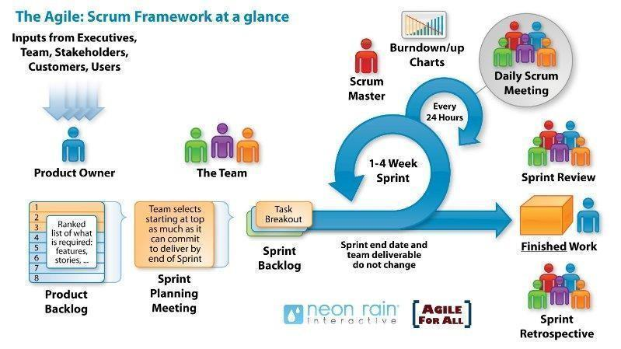
Figure 1. Scrum process
- Scrum is an iterative and incremental agile software development framework for managing software projects and product or application development.
- Scrum focuses on project management institutions that are difficult to plan
- Mechanisms of empirical process control, where feedback loops that constitute the core management technique are used as opposed to traditional command-and-control management.
- Its approach to planning and managing projects is to bring decision-making authority to the level of operation properties and certainties.
Why did we choose the Scrum process to develop the system?
- Choose Scrum for its flexibility and iterative nature.
- Easily adapts to changing needs and new features.
- Continuous improvement through sprint feedback.
- Early issue detection and resolution.
- Reduces risks from inexperience and changing requirements

11.2. Development Plan
Table 7. Development Plan
No. | Task Name | Start | Finish | No. | Task Name
1 | Initial | 01/02/2026 | 07/02/2026 | 1 | Initial
1.1 | Gathering Requirement | 01/02/2026 | 04/02/2026 | 1.1 | Gathering Requirement
1.2 | Create Proposal Document | 05/02/2026 | 07/02/2026 | 1.2 | Create Proposal Document
2 | Start-Up | 08/02/2026 | 14/02/2026 | 2 | Start-Up
2.1 | Project kick-off | 08/02/2026 | 10/02/2026 | 2.1 | Project kick-off
2.2 | Create Document | 11/02/2026 | 14/02/2026 | 2.2 | Create Document
3 | Development | 01/02/2026 | 30/04/2026 | 3 | Development
3.1 | Sprint 1 | 01/02/2026 | 28/02/2026 | 3.1 | Sprint 1
3.2 | Sprint 2 | 01/03/2026 | 31/03/2026 | 3.2 | Sprint 2
3.3 | Sprint 3 | 01/04/2026 | 25/04/2026 | 3.3 | Sprint 3
4 | Release | 26/04/2026 | 30/04/2026 | 4 | Release

12. System Architecture Overview
12.1 System context diagram
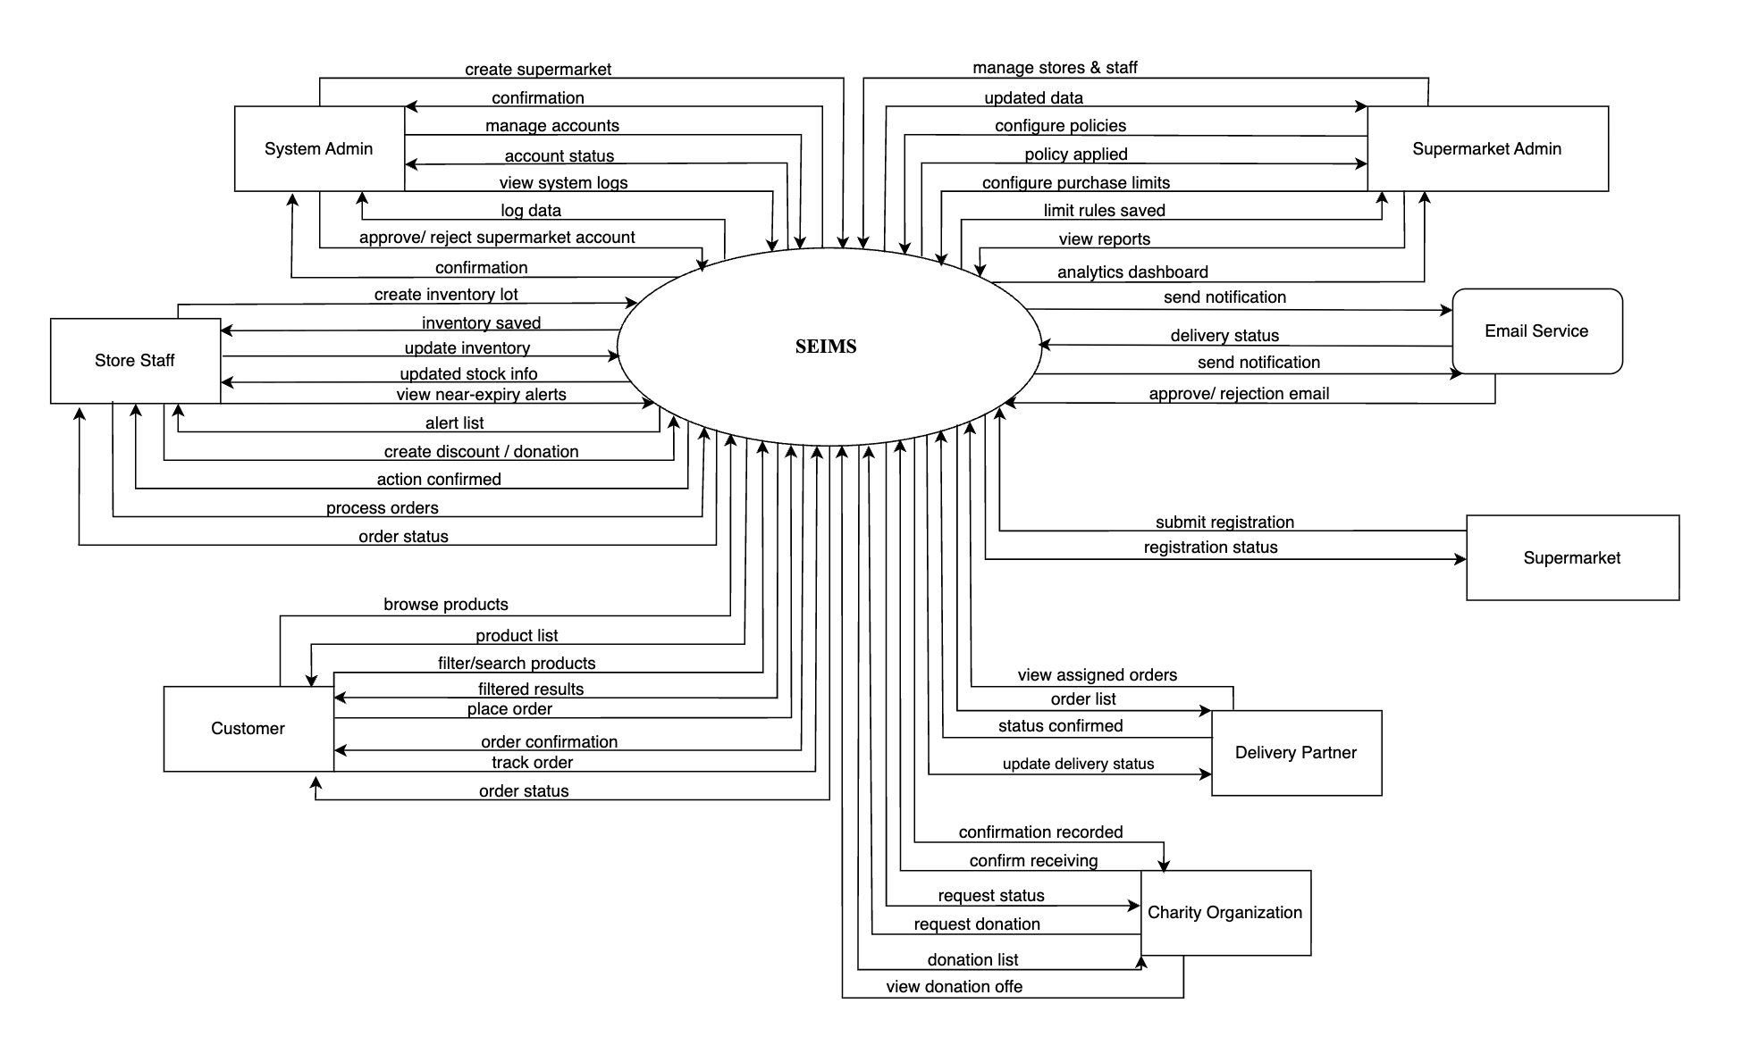
Figure 2. Context diagram

12.2 System context diagram description
- Supermarket:
- Submit registration form
- Submit registration request
- Receive registration status notification
- Admin:
- View pending registration list
- Display supermarket information
- Approve registration
- Confirmation successful
- Management Supermarket Admin
- Supermarket Admin:
- Store Management
- Store Staff Management
- Display Employee Information
- Update Policy (Expiration Dates, Discounts)
- Confirm Update Successfully
- Store Staff:
- Batch Inventory Management
- Display information
- Track donations
- View order details
- Update status
- Order Management
- View statistics
- Customer:
- View products nearing their expiration date
- Place an order
- Confirm your order
- View your order history
- View details
- Track your delivered order
- Charity Organization:
- View products nearing their expiration date
- Place an order
- Confirm your order
- View your order history
- View details
- Track your delivered order
- Delivery Partner:
- View delivery details
- Update delivery status
- Track delivery history
- Email Service (Third-party system):
- SEIMS sends email sending request
- Email Service confirms successful sending

13. Potential Risks and Mitigation Strategies
Table 8: Risk
Risk Category | Specific Risk | Likelihood | Impact | Mitigation Strategy
Technical | Incorrect inventory lot entry (wrong expiry date or quantity) | Medium | High | Implement strict input validation and user input constraints for expiry date and quantity. Provide clear input guidelines and error messages to prevent incorrect data entry.
 | System performance issues when processing large inventory datasets | Medium | Medium | Optimize database queries using indexing, implement pagination, and apply caching mechanisms (e.g., Redis) to improve performance and scalability.
Security | Unauthorized access across supermarkets (multi-tenant data leakage) | Low | High | Enforce strict RBAC and isolate data by Supermarket ID.
Operational | Store Staff delay in handling near-expiry products | Medium | High | Implement automated alerts and dashboard warnings for overdue handling.
Legal | Accidental listing of expired products | Low | High | Prevent expired lots from being published through automatic validation rules.
Data | Inaccurate imported Excel/CSV data | Medium | Medium | Validate file format and provide preview before confirmation.
Schedule | Delay in implementing rule engine or donation workflow | Medium | Medium | Prioritize core modules early and apply sprint-based development planning.
Resource | Limited real supermarket data for testing | High | Medium | Use simulated multi-supermarket datasets for system testing.

14. Expected Outcomes/ Deliverables
Table 9. Project Deliverables and Descriptions
Deliverable | Description
Application | A fully functional web-based Near-Expiry Product Management Platform supporting multi-supermarket management, inventory lot tracking, near-expiry detection, discount rules, donation workflow (B2B), and marketplace features (B2C).
Source Code | Complete source code of the web application (Frontend: React, Backend: Flask API, Database: MySQL/SQLite), properly structured and version-controlled for future maintenance and expansion.
Technical Documentation | Proposal, Project Plan, System Architecture Design, Database Design (ERD), API Documentation (Swagger), User Interface Design, Test Plan, and Deployment Guide.
Demo Video | A recorded demonstration showcasing key workflows such as inventory lot entry, near-expiry detection, discount application, donation process, customer ordering, and order completion.
Final Report | A formal project report summarizing objectives, methodology (Scrum), system design, implementation details, testing results, challenges, limitations, and future improvements.

15. References
Table 10. References
No. | References | Document Information
1 | Scrum Model | https://en.wikipedia.org/wiki/Scrum_(software_development)
 |  | https://www.atlassian.com/agile/scrum
 |  | https://www.digite.com/agile/scrum-methodology/
 |  | https://www.scrum.org/resources/scrum-guide
2 | Technical | https://www.tensorflow.org/tutorials/quickstart/beginner?hl=vi
 |  | https://www.flutterclutter.dev/flutter/tutorials/implementingedge-detection-in-flutter/2020/1509/
 |  | https://stackoverflow.com/questions/14248571/findingproperties-of-sloppy-hand-drawn-rectangles
 |  | https://www.tutorialspoint.com/how-to-detect-a-rectangle-andsquare-in-an-image-using-opencv-python
 |  | https://platform.openai.com/docs/overview
 |  | https://www.mysql.com/docs/
 |  | https://pytorch.org/
 |  | https://opencv.org/
3 | Standard | https://www.nws.noaa.gov/oh/hrl/developers_docs/General_So ftware_Standards.pdf
 |  | https://standards.ieee.org/standard/12208-2017.html
 |  | https://en.wikipedia.org/wiki/Scrum_(software_development)

